Experiment No:-2

Aim:- Write a program to check whether a string belongs to the grammar or not.

Algorithm:

Start.
Declare two character arrays str[],token[] and initialize integer variables a=0,b=0,c,d. Input the string from the user.
Repeat steps 5 to 12 till str[a] =’\0’.
If str[a] =='(' or str[a] =='{' then token[b] =’4’, b++.
If str[a] ==')' or str[a] =='}’ then token[b] =’5’, b++. Check if isdigit(str[a]) then repeat steps 8 till isdigit(str[a]) a++.
a--, token[b] =’6’, b++.
If str[a]=='+’ then token[b]='2',b++. If(str[a]=='*') then token[b]=’3’,b++. a++.
token[b]='\0';
then print the token generated for the string . b=0.
Repeat step 22 to 31 till token[b]!='\0' c=0.
Repeat step 24 to 30 till (token[b]=='6' and token[b+1]=='2' and token[b+2]=='6') or (token[b]=='6' and token[b+1]=='3'and token[b+2]=='6') or (token[b]=='4' and token[b+1]=='6' and token[b+2]=='5') or (token[c]!='\0').
token[c]='6'; c++;
Repeat step 27 to 28 till token[c]!='\0'. token[c]=token[c+2].
c++.
token[c-2]=’\0’. print token. b++.
Compare token with 6 and store the result in d.
If d=0 then print that the string is in the grammar. Else print that the string is not in the grammar.
Stop.

Program:
#include<stdio.h>
#include<conio.h>
#include<ctype.h>
#include<string.h> void main()
{
int a=0,b=0,c;
char str[20],tok[11]; clrscr();
printf("Input the expression = "); gets(str); while(str[a]!='\0')
{
if((str[a]=='(')||(str[a]=='{'))
{
tok[b]='4'; b++;
}
if((str[a]==')')||(str[a]=='}'))
{
tok[b]='5'; b++;
}
if(isdigit(str[a]))
{
while(isdigit(str[a]))
{

}
a--;
a++;

tok[b]='6'; b++;
}
if(str[a]=='+')
{
tok[b]='2'; b++;
}
if(str[a]=='*')
{
tok[b]='3'; b++;

} a++;
}
tok[b]='\0'; puts(tok); b=0;
while(tok[b]!='\0')
{

if(((tok[b]=='6')&&(tok[b+1]=='2')&&(tok[b+2]=='6'))||((tok[b]=='6')&&(tok[b+1
]=='3')&&(tok[b+2]=='6'))||((tok[b]=='4')&&(tok[b+1]=='6')&&(tok[b+2]=='5'))/*||((tok[b
]!=6)&&(tok[b+1]!='\0'))*/)
{
tok[b]='6'; c=b+1;
while(tok[c]!='\0')
{
tok[c]=tok[c+2]; c++;
}

}
int d;

}
else
{

}
tok[c]='\0'; puts(tok); b=0;

b++;
puts(tok);

d=strcmp(tok,"6"); if(d==0)
{

}
else
{

}
printf("It is in the grammar.");

printf("It is not in the grammar.");

getch();
}

Output:

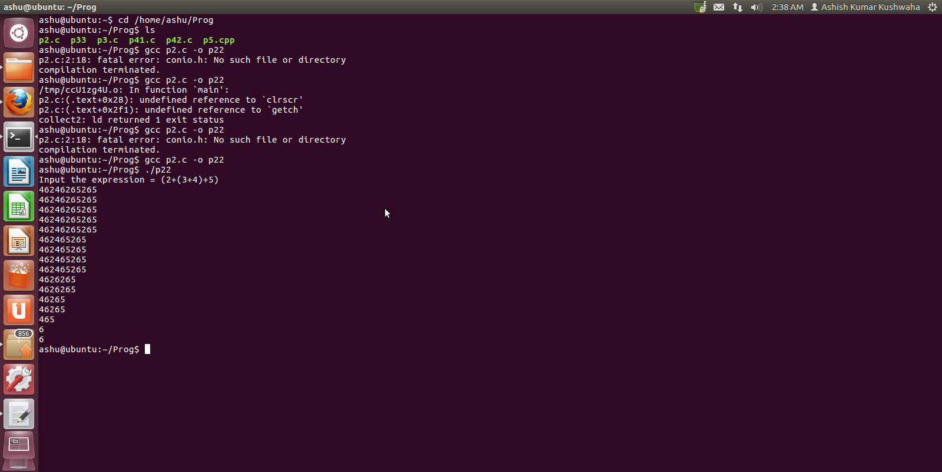

Conclusion: Thus we have executed program to check whether a string belongs to the grammar or not.

